April 12th, 2009
Hi
Just think. By the time I got up today and was ready to start this letter, I had just finished my run of yesterday. Started the run early at 0815 and finished at 1035. The first part of the run was along Tai Tong Road to the end then back along the track to the reservoir, where, Leonie, we ran a few years ago with Prem. Then to Sek Kong army camp. Probably only two more runs this season which would make a total of only 20. I lost two weeks because of the injured heel (which is still not fully healed) and another two at the start of the season by being in Indonesia.
A man in a village near Tai Po was chased and bitten in the crotch by a wild boar the other day! Those animals certainly know where to aim for. I think this was somewhere near the place where I was also chased, but not bitten. The report also said there are wild pigs in the Shing Mun reservoir area (where we hiked, Leonie and Tom) and in the Tai Lam Chung reservoir area, where I was yesterday. But although I have run many times in both areas, I have never seen any evidence of pigs.

On Wednesday I went to the hospital for the BCC check-up. Again nothing. I have learnt to take things to do for these appointments. At ‘priority level 6’ (the lowest) I am one of the last to be seen and sometimes have to wait for nearly two hours!

Also this week, there were two Nobel Prize winning economists in HK to give lectures. One of these was the guy (John Nash?) whose life story was (supposedly) told in the movie ‘A Beautiful Mind' (which I did not see).
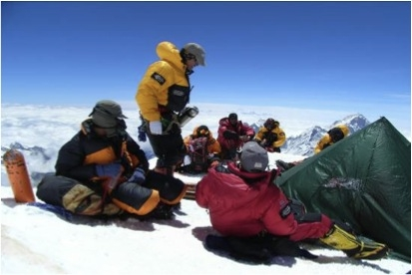
There has been an interesting BBC TV documentary on medical researchers who are interested in finding out the effects of hypoxia (low oxygen levels) on performance and survival, aimed at improving the care of the critically ill and other patients where hypoxia is an issue. As part of the investigation (which is what the documentary was about), they climbed Mt Everest, doing experiments and taking blood samples on the way up including on the summit. At the top, one of the team had a pO₂ level of just 3.5. Do you know what this means? They commented that with such a level he should not be alive! Also, they recruited volunteers from all walks of life and ages (the oldest was 73) who took a month off work for the study. They just hiked up to the base camp, but did not climb Everest itself. Preliminary findings suggest that age and fitness are not necessarily key factors and that genetic makeup may also be important. I wanted to compare the pO₂ = 3.5, so I looked up my record from when I had the almost fatal asthma attack in California in 1985; however, pO₂ levels were not given, though pCO₂ levels were. Websites for the medical study:
Home:
http://www.xtreme-everest.co.uk/index.php
The research:
http://www.xtreme-everest.co.uk/news_main.php?tag=science
Publications:
http://www.xtreme-everest.co.uk/news_detail.php?article=673

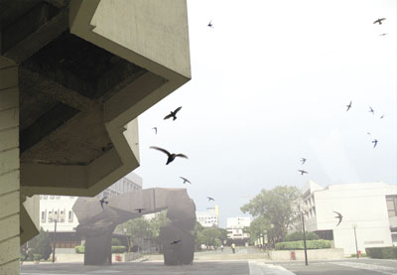
The Chinese University is to expand its main library building. However, the way the building is constructed has made it ideal for house swifts where about 500 of them. Swifts have made it home for about 30 years though I must say I did not know of this. (Unlike other birds, house swifts only have short legs that are good for clinging to vertical surfaces; they never land on the ground because they cannot take off again if they do.) CU is to relocate swifts to another portion of the building.
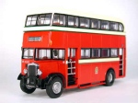
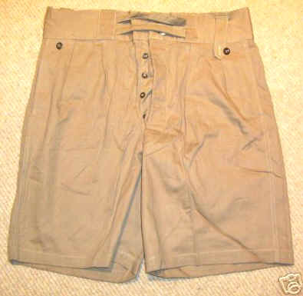
KMB 'celebrates' 60 years of using double-decker buses. This first model (picture) was used from 1949 to 1983. I remember them very well, though not necessarily with enthusiasm. They were non air-conditioned and were almost always so crowded that sardines in a can are well off. No Octopus cards of course. Each bus had two conductors from whom you bought a ticket. It was hot for the drivers as the engine was next to them. Also, there was no power steering’ the steering was so heavy that drivers sometimes had to ask passengers to turn the steering wheel! I remember clearly the ‘uniform’ of the drivers. Many wore sandals, a white vest and ‘Bombay bloomers’ (the kind of long very wide khaki shorts that British soldiers of the WWII era used to wear in the tropics).
That’s about it for now.
Cheers

